Article

Planning and Scheduling of a Construction Renovation Project Using BIM-Based Multi-Objective Genetic Algorithm

Pornpote Nusen 1, Wanarut Boonyung 2, Sunita Nusen 3, Kriengsak Panuwatwanich 4,   
Paskorn Champrasert 2 and Manop Kaewmoracharoen 2,*

1 Department of Civil Engineering, Faculty of Engineering, Chiang Mai University, Chiang Mai, 50200,   
Thailand; pornpote_n@cmu.ac.th

2 Optimization Theory and Applications for Engineering SYStems Research Group (OASYS), Chiang Mai University, Chiang Mai, 50200, Thailand; wanarut.b@gmail.com (W.B.), paskorn@eng.cmu.ac.th (P.C.), manop@eng.cmu.ac.th (M.K.)

3 Department of Civil and Environmental Engineering, Faculty of Engineering, Rajamangala University of Technology Lanna, Chiang Mai, 50300, Thailand; sunita@rmutl.ac.th

4 School of Civil Engineering and Technology, Sirindhorn International Institute of Technology,   
Thammasat University, Pathum Thani, 12120 Thailand; kriengsak@siit.tu.ac.th

* Correspondence: manop@eng.cmu.ac.th; Tel.: +66-53-944-157

**Featured Application: Building information modelling with multi-objective genetic algorithm**

**Abstract:** Construction renovation is known to be a complicated type of construction project and prone to errors compared to new construction. The need to carry out the renovation work while keeping normal business activities running, coupled with strict governmental building renovation regulations, presents an important challenge affecting construction performance. Given the current availability of robust hardware and software, building information modeling (BIM) and optimization tools have become essential tools in improving construction planning, scheduling, and resource management. This study explored opportunities to develop a multi-objective genetic algorithm (MOGA) on existing BIM. The data were retrieved from a renovation project over the 2018-2020 period. Direct and indirect project costs, actual schedule, and resource usage were tracked and retrieved to create a BIM-based MOGA model. After 500 generations, optimal results were provided as a Pareto front with 70 combinations among direct costs, time usage and resource allocation. The BIM-MOGA also provided less computation time compared to previous studies. It can be used as an efficient tool for construction planning and scheduling using a combination of existing BIM along with MOGA into professional practices. This approach would help improve decision-making during the construction process based on the Pareto front data provided.

**Keywords:** construction renovation; planning; scheduling; building information modeling; multi-objective genetic algorithm; resource utilization

1. Introduction

Nowadays construction management is facing several uncontrollable and controllable challenges. Unpredictable weather, local resource scarcity and a range of strict regulations are common uncontrollable factors in the construction industry. Traditional construction management also deals with controllable factors such as inconsistent design, lack of constructability, inaccurate documentation, and redundant work processes. Building information modeling (BIM) has been widely used for a decade to improve the efficiency of a construction project, especially in construction planning and documentation. It provides data and visualization to project managers to make better decisions for improved quality and faster processes [1]. Through clash detection capability, BIM also helps resolve design conflict resulting from the complex interface between various building elements which commonly exist in large buildings and renovation work [2]. Construction complexity has a direct impact on project communication and performance [3]. Construction renovation projects are particularly complex because of physical constraints, such as obsolete conditions, limited access and unknown conditions. Some renovation projects become more complex if there is a requirement for the business to remain open during the renovation. The contractors are required to take extra care in planning in order to ensure that the construction activities do not interfere with on-going business.

The apparent benefit of BIM in dealing with the technical complexity of a construction project has seen a widespread adoption of BIM technology as a tool to improve efficiency in construction management. Recently, an artificial intelligence optimization approach has been suggested to further enhance BIM capability. Such an advancement represents a research opportunity to develop and apply a BIM-based optimization approach to existing traditional construction approaches.

1.1. Building Information Modeling

Building information modelling (BIM) was introduced in the early 2000s as an information model of building elements. It has been widely used in the construction industry since then because it enables better project information flow throughout a building life cycle, from pre-construction to construction, post construction, and operation. It is used for the improvement of planning and design, clash detection, visualization, cost planning, and data management. A BIM model consists of (1) physical properties in three dimensions, such as material, density, weight, or location; and (2) embedded information, such as construction specifications or repair manuals. Several researchers and practitioners have used BIM in a variety of aspects. Most notably, it is used to improve communication between the project stakeholder over a traditional non-BIM approach [4] and to improve information synchronization of building coordination in a three-dimensional space. This is a significant improvement on traditional construction drawings and is very useful for complex projects such as extra-large buildings that require synchronization between multi-disciplinary parties as well as multi-source documents [5]. The integration of BIM-based quality management model is also suggested [6].

BIM has been used for existing buildings in either renovation projects or for the improvement of existing facilities. Facility management [7] and sustainability improvement for existing buildings are the major benefits of BIM [8]. It also significantly improves construction processes when working on existing buildings; however, several challenges need to be addressed, including the difficulty of stakeholder involvement and the lack of automated data capturing [9]. In converting existing buildings to BIM, laser scanning surveyance and total station techniques are suggested [10]. This technique is also used for collecting historical building information [11]. It can be seen that using BIM as a tool for a complex renovation project is viable for making the project more successful.

1.2. Construction Planning and Scheduling Optimization

Construction planning and scheduling are the most important activities during the pre-construction phase. A well planned and optimized construction schedule contributes significantly to a successful project. Several researchers adopted optimization techniques to solve construction planning and scheduling problems. In the past, linear programming was one of the techniques most widely used to solve this issue. Multi-objective linear programming is suggested for optimization when faced with constrained resource problems, including construction costs, project duration, resource idle time, and project delivery time [12].. A particle swarm optimization is also suggested for construction scheduling problems in order to solve resource constraint issues [13]

An ant colony optimization, which focuses on minimizing project duration while varying activity sequences, is another approach for resource-constrained projects [13]. Genetic algorithms (GA) have been used in several construction scheduling research problems, such as resource allocation and leveling optimization [14], concrete precast production optimization [15], and nonproductive resource determination [16].

In real construction projects, there are always multiple objectives forming a set of solutions as optimization data for project managers to make decision. Multi-objective genetic algorithms (MOGA) were first introduced by Tadahiko Murata in 1995 to provide decision makers with Pareto optimization instead of constant weights [17]. It has been discussed in several construction optimization studies. For example, it is used for construction time-cost trade off optimization [18] by defining optimal time and cost with variable crane locations and crews by minimizing crane stoppage time [19]. It is also used to improve safety by optimizing safety costs on different project layouts [20]. Even construction quality is used as an objective function for MOGA along with construction project time and cost with the results showing their weights and Pareto solutions [21]. The optimization results can be used for the decision maker in another application such as planning, scheduling, or even unpredictation situation such as construction logistics network during hazard [22].

A combination of BIM and optimization techniques has been used to improve information flow and visualization. An optimization technique such as genetic algorithm (GA) was used with BIM for possibilities usage of information from BIM directly and parsing it to data to GA directly [23]. More than the fuzzy-logic dataset was possibilities usages in GA for construction scheduling [24]. Other applications of BIM-based optimization were used for the construction assembly line [25] and building energy performance evaluation [26].

In this paper, the authors integrate ideas from previous studies to develop a BIM-based MOGA. A case study of the renovation of an extra-large building project was used to validate the proposed BIM-based MOGA.

2. Materials and Methods

2.1. Project Background

A renovation project of Chiang Mai University Main Library, with a size of 15,768 square meters and built in 1964, was used in this research. The exterior and interior of the building are displayed in Figure 1. The renovation was approved by the University in 2015 and started in 2018, with a budget of 86,000,000 baht (approx. 2,350,000 Euro). The project’s challenges were (1) the requirement for regular operating hours with only partial closure, (2) extra-large building regulations, as defined by the Thailand Ministerial Regulations ACT 33 B.E. 2535 (announced in 1992), and (3) complicated governmental-university regulations.

The project started on the 17th October 2018, with a construction duration of 720 days. The proposed schedule was divided into four phases: (1) the 4th floor renovation from day 1 to 180, (2) the 3rd floor renovation from day 181 to 360, (3) the 2nd floor renovation from day 361 to 540, and (4) the 1st floor renovation and landscape from day 541 to 720. The project was finally completed on the 2nd November 2020, after an extension period of 36 days. The project scopes were to improve the current look and atmosphere of the building, update MEP (mechanical, electrical and plumbing) and ICT systems to modern standards, and to revamp the landscape and surrounding area with a new concrete patio.

|  |  |
| --- | --- |
| (**a**) | (**b**) |

**Figure 1.** Project site of Chiang Mai University Library prior to renovation: (**a**) Exterior view from the west side; (**b**) Interior view on the first floor.

2.1.1. Construction Scheduling

Before the project commenced, the project schedule was initially set according to the project contract. Information was extracted from the contract, which consisted of a project delivery system, bill of quantities (BOQ), resources, phasing, and payment. Then, during the construction, the actual schedule and resources usage were retrieved on-site from daily site progress reports. The first phase focused on the demolition of existing walls and removing existing ceilings and floors. Then, the project closed each floor, starting with the 4th floor, while the 1st, 2nd, and 3rd floors remained operational as usual.

The original scheduling data were retrieved from the main contractor in the form of Microsoft Project and Microsoft Excel files. Over two years, on-site data were collected, including the number of workers, crew sizes, actual durations, and project progress. Then, all data from different sources were used to create the BIM.

2.1.2. BIM Model Development

The original design of the building is illustrated in Figure 2 as an as-built drawing. However, over 50 years there had been several minor renovations and modifications which were not recorded in any hardcopy format. A BIM was developed based on as-is condition from the as-built drawing, terrestrial laser scanning survey data, and on-site survey data.

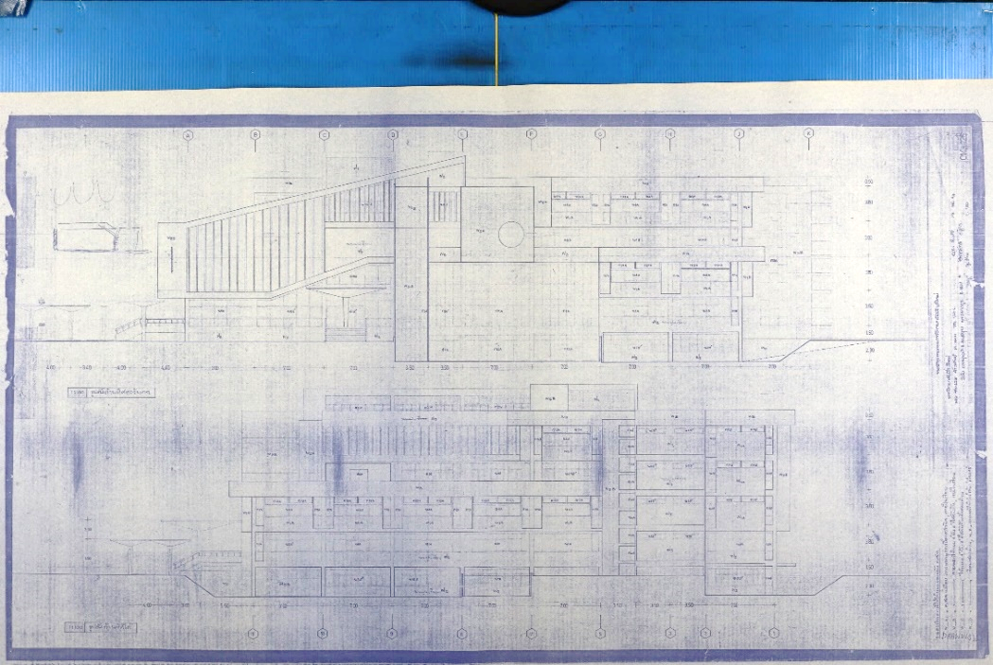

**Figure 2.** Chiang Mai University Library as-built drawing blueprint from 1964.

The BIM of the renovation project was initially created based on the as-built drawing; however, several details were missing either due to faded blueprints or non-recorded renovation activities. Moreover, information from a traditional two-dimension blueprint was obscure and prone to error due to several unconnected figures, tables and remarks. Then, a traditional on-site survey along with a terrestrial laser scan was carried out in order to collect as-is condition of the building and the surrounding area. Three-dimensional point cloud data were retrieved from the survey. Then, the point cloud data were laid on top of the existing as-built drawings to complete the building information. When data from different sources were combined, discrepancy data appeared, as illustrated in Figure 3 which shows an example of an opening position error when comparing the as-built drawings and as-is condition. Today, this approach is a typical initial BIM procedure for gathering data in renovation projects.

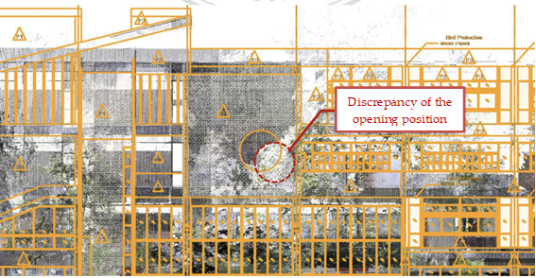

**Figure 3.** Point cloud dataset from terrestrial laser scanner overlaid on the existing building and its   
surrounding of Chiang Mai University Library.

Following the above procedure, the BIM was created for visualization of the project (3D BIM) and the project schedule (4D BIM). Figure 4 displays the 3D BIM model for visualization. It displayed the final appearance when the renovation was completed. This was used for communication between project stakeholders. The scheduling and cost data model are displayed in the BIM from a combination of the 3D BIM and a project Gantt chart, as illustrated in Figure 5. The appearance of building elements was changed and highlighted according to a specific date. This allowed the project stakeholders to discuss and monitor the current project schedule in an efficient manner. Moreover, the 4D BIM renovation was helpful since several demolition tasks were not displayed in the model but required significant project resources. This allowed the project stakeholders to plan and schedule for non-element construction tasks much more easily than in a traditional approach. In this 4D BIM, a demolition model and a new renovation model were overlapped for planning and scheduling in different project phases.

During construction, schedule and resource information was collected on site and put back into the model for control and monitoring. Finally, total cost data were then used for project management throughout the project life cycle.

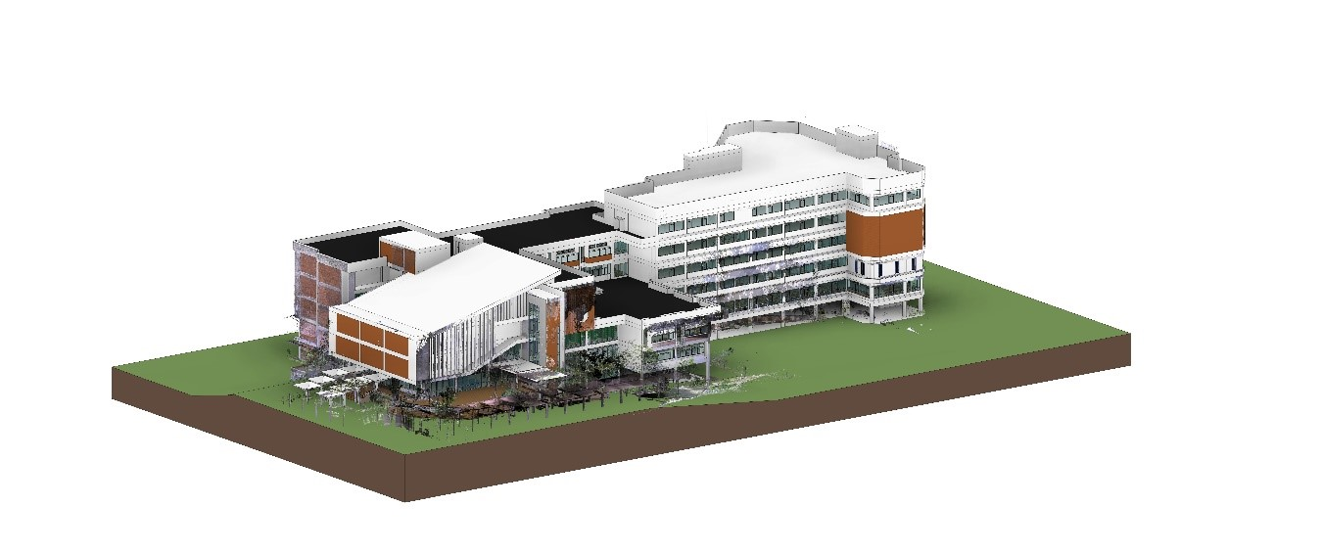

**Figure 4.** Rendered BIM model of Chiang Mai University Library for visualization.

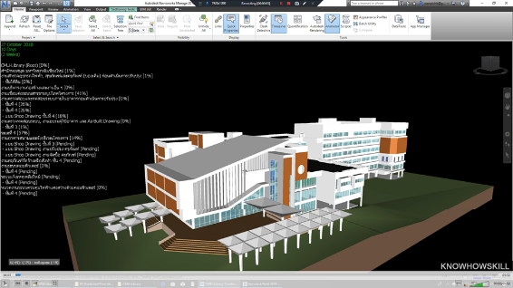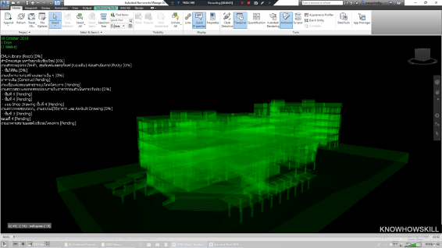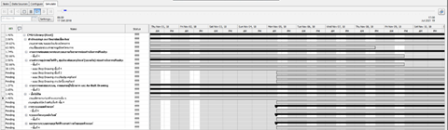

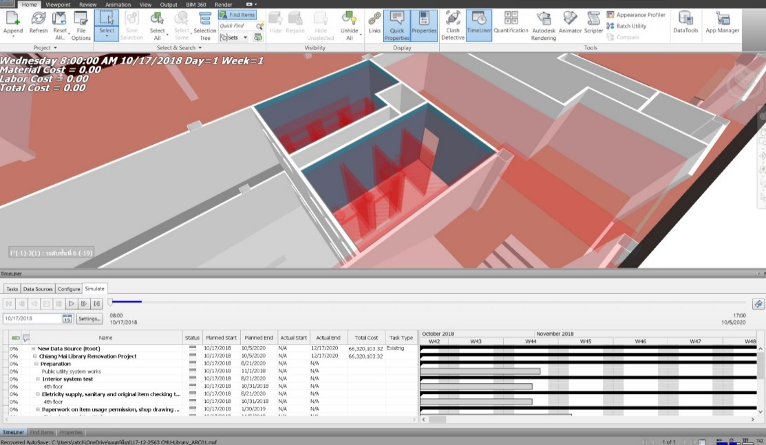

**Figure 5.** BIM models with Gantt chart scheduling

2.2. Optimization Definitions

The optimization problem for the multi-objective optimization was defined with the goal of minimizing total cost, construction time, and variance in the number of workers per day. The revelent parameters and associated formula are presented below.

|  |  |
| --- | --- |
| *Total cost (Ct)*  *=*  *DC + IC + LPF* | (1) |
| *Direct cost (DC)* *= MC + LC* | (2) |
| *Indirect cost (IC) = Indirect factors × Ta* | (3) |
| *Late penalty fee (LPF) = Daily penalty fee × (Ta – Tc)* | (4) |

where DC is the direct cost; IC is the indirect cost; DC+IC is the contract price ; LPF is the late penalty fee; MC is the material cost; LC is the labor cost; Ta is the actual construction time; and Tcis the contract construction time.

|  |  |
| --- | --- |
| *Actual construction time (Ta) = Max FTi* | (5) |

where *FTi* is the finish time of activity i.

|  |  |
| --- | --- |
| $${Number of workers per day }_{t}=\sum_{i=1}^{n}{\left(\frac{Q_{i}}{D_{i} {PDR}_{i}}\right)}$$ | (6) |
| $$Workers utilization fluctuation(Mx)=\sum_{t=1}^{T}{{[{Number of workers per day }_{t}]}^{2}}$$ | (7) |

where n is the total number of activities in day t; Qi is the Quantity of activity i; Di is the Duration of activity i; PDRi is the Productivity rate of the worker for activity i; and T is the total number of project working days.

2.3. Problem Definitions

Optimizing project cost, duration, and resouce usage while maintaining the BIM data collection is crucial for this research. Typically data in BIM itself are interconnected to the 3D model and schedule to enable 4D modelling with an automatic update of scheduling information. However, when dealing with a complex solution, BIM requires external optimization tools and needs to leave the BIM data pipeline. This causes redundant manual tasks which are prone to error. The goal was to optimize those objectives and exchange data back and forth via BIM. To satisfy these requirements, BIM can be used to embed information into a three dimensional representation [23] [24] and then connected to multi-objective genetic algorithm (MOGA) for solving multi-objective problems. At the end optimal Pareto front is provided for decision makers instead of static objective weights for cost, duration, and resource.

3. BIM-MOGA Model

In this section, the development of BIM-MOGA is described. By retrieving project information from the BIM, the MOGA process solves multi-objective optimization problems using GA. In doing so, a Pareto front must be firstly defined. Once the Pareto front has been defined, the best solution will then be chosen by the decision makers. The renovation scheduling was generated by Microsoft Project. After that, the researchers exported the file to Autodesk Navisworks and exported the BIM from Autodesk Revit to Autodesk Navisworks in order to create a 4D BIM for the renovation project. This allowed the concerned parties to monitor the process and reduce workloads and conflicts while working at the site. It also helped improve collaboration between the concerned parties. Each related part is explained in detail in the following sections.

The proposed model is a multi-objective optimization for minimizing project duration, cost, and resources simultaneously. The steps to generate an optimized schedule are illustrated in Figure 5. The optimization model is developed and organized into three main modules: 1) Initialization Module: Construction data are calculated i.e., an initial project schedule and the number of total float days; 2) BIM Module; and 3) MOGA Module. These three main modules are described in more detail in the following sections.

2D plan

Planned schedule

Actual schedule

Budget cost

Actual cost

Construction data

3D model

4D model

BIM model

BIM

BIM visualization

Optimization model

Decision variables

Genetic operations

Pareto front

MOGA

**Figure 5.** The flow diagram of optimization procedure.

3.1 Initialization Module

There are three main calculations for this module as listed.

3.1.1 Actual construction time (Ta) calculations

The calculation used construction data from each activity and project calendar constraint, i.e., activity duration (Di), activity sequence and exception date (ei) from the baseline schedule. The precedence networks were created using Precedence Diagram Method (PDM). In PDM, there are four precedence relationship constraints: Finish to Start (FS), Start to Start (SS), Finish-Finish (FF) and Start-Finish (SF) with overlapping time (Li). The PDM calcuation procedure used sequential forward and backward calculations via the network to calculate the early start times (STi) to early finish times (FTi), and late start times (LSi) to late finish times (LFi) for each activity. From these values, actual construction time (Ta) and total float time (TFi) were determined using eq.5, as presented previously, and eq.8 below.

|  |  |
| --- | --- |
| $$TF_{i}=LF_{i}-{FT}_{i}-D_{i}-ⅇ_{i}+1$$ | (8) |

where *TFi*= total float of activity *i*

3.1.2 Resource utilization fluctuation (Mx) calculations

The resource utilization fluctuation, also known as the static moment Mx, is calculated by summing the total numbers of daily fluctuations in eq 6-7. The flucutation numbers were calculated from each acitiviy i (Qi) and each worker productivity rate i (PDRi).

3.1.3 Total Cost (Ct) calculations

Total cost (Ct) is calculated using eq.1, which is referred to as direct cost (DC), indirect cost (IC) and late penalty fee (LPF). DC is calculated using eq.2 which includes material cost and labor cost, with material cost being a function of material quantity from BIM as shown in eq.9 and labor cost being the function of daily payrate of workers as shown in eq.10. IC is calculated using eq.3 and LPF is calculated using eq.4 as presented earlier.

|  |  |
| --- | --- |
| $$Material cost(MC)=\sum_{i=1}^{N}{[{Material cost unit rate}_{i} Q_{i} ] }$$ | (9) |
| $$Labor cost(LC)=\sum_{t=1}^{Ta}{[{Number of workers per day }_{t} {Pay rate }_{t} ] }$$ | (10) |

3.2 BIM Module

Once the construction data were calculated, they were transferred to the BIM module. BIM enabled the concerned parties to see the 3D visualization of the project in its current stage. A collision check was conducted before the start of the construction to identify any visible clash between building elements. The schedule planning was correlated with the model. The BIM-based schedule was integrated to the 4D model and used as a visualization tool. The Activity ID generated by the 4D BIM was used to link schedules with 3D objects. To create the actual construction stimulation, actual work start time and end time were fed into the model. Resources and cost were also monitored. The “BIM Model” was used during the process as a dynamic management process simulation of project progress. A baseline schedule providing required BIM data was subsequently imported to the optimization module.

3.3 MOGA Module

The MOGA module starts by defining optimization objectives, constraints, and project parameters. The parameters which are retrieved from construction data are project activities, activity predecessors, successors, resource availability, cost data and project calendars. Then, a genetic algorithm optimizer is employed. Once the MOGA process is complete, several optimal solutions are obtained as a Pareto front. The data is then used in BIM for scheduling, budgeting, and planning for different optimal alternatives. This allows a decision maker to select an optimum solution from a set of solutions based on construction project constraints.

3.3.1 Optimization Model

To minimize three objectives as listed in eq. 11 to 13, the nondominated sorting genetic algorithm 2 (NSGA-II) [25] is used for a problem with different scales and units. It is used instead of a popular weighted-sum genetic algorithm approach [26] because the weight-sum technique needs weight values. the weight values are multiplied with three objective values then they sum each other and become one objective. The problem is that the three objectives are different units and scales. It may converge only one objective. Several optimal solutions for multi-objective problems are obtained with the following objectives and constraints.

Objectives:

|  |  |
| --- | --- |
| *Minimize f1(s, x) : Ta* | (11) |
| *Minimize f2(s, x) : Ct* | (12) |
| *Minimize f3(s, x) : Mx* | (13) |

where Ta is the actual construction time, Ct is the total cost, Mx is the worker utilization fluctuation moment, *s* is the shifting time set, and *x* is the predecessor option set.

Constraints:

|  |  |
| --- | --- |
| $$Ta≤ Maximum Contract days$$ | (14) |
| $$r_{xt}≤{MWA}_{x}$$ | (15) |
| $$LPF≤10\% of Contract price$$ | (16) |

where $r_{xt}$ is the worker demand type-*x* on day *t; ${MWA}_{x}$*  is the maximum worker availability of resource type *x;* and LPF is the late penalty fee.

This study considers four types of resource, namely general workers, skilled carpenters, sanitary plumbers, and electricians. LPF is calculated from the construction contract, and is not allowed to be greater than 10% of the total contract cost, otherwise the contract will be terminated.

3.3.2 Decision variables

Each solution comprises an N number of blocks as displayed in Figure 6. Each block represents individual problem decision variables providing two different values. The first value is the number of shifting times from the original plan, while the second value is a predecessor activity option.

|  |  |
| --- | --- |
| $$0≤S_{i}≤TF_{i}$$ | (17) |
| $$0≤x_{ihg}≤1$$ | (18) |

where *Si* is the shifting time of activity *i*; *TFi* is the total float of activity *i*; and *Xihg* is the predecessor option between h or g of activity *i*.

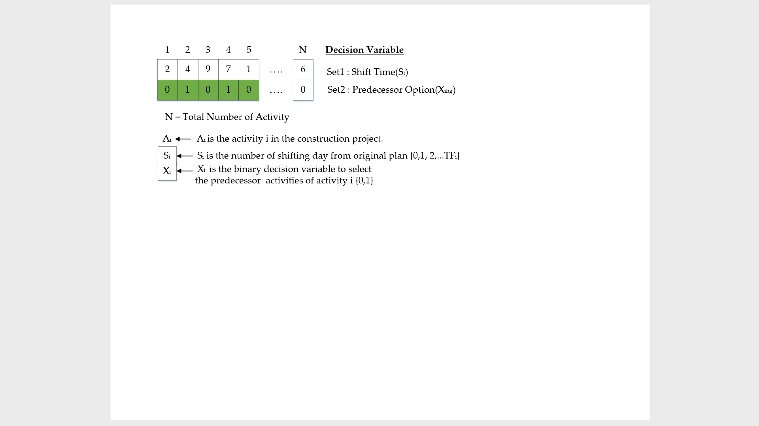

**Figure 6.** Solution structure for GA operation.

Initial decision variables are a data set where:

Set1: Defines shifting time and sets lower and upper bounds   
(Si = 0 to total float of activity i)

Set2: Defines predecessor option (Xihg) and sets lower and upper bounds   
(Xihg = [0,1])

The predecessor option is defined (Xihg) and optimal scheduling is now processed by considering both Set1 and Set2 options. The Set2 option is proposed based on construction renovation project characteristics, including additional levels of uncertainties and particular management issues. If the interactive planner’s viewpoint is obtained, selecting the Set2 option can provide more efficient optimal scheduling. The shifting time and predecessor option are two sets of decision variables with 250 total number of activities for all decision variables. The population size is chosen as 500, as suggested in previous research for double or quadruple design variables [27].

3.3.3 Genetic Operations

By performing GA operator, a next generation population is created based on fitness value calculations using GA, including a selection, crossover, and mutation. The selection technique depends on a uniform random mechanism. The crossover is performed using a one-point crossover routine. The mutation is performed by uniform randomization around old variable values. The number of mutations proportionally changes based on the setting of the mutation rate between the value of 0 and 1 [28]. The GA steps are listed below, with the pseudocode displayed in Figure 8.



**Figure 8.** Main loop pseudocode.

1. Population Creation: in each solution, the shifting time set values (Set1) and predecessor option set values (Set2) are randomized. Set1 is uniformly randomized from 0 to a sigma parameter value, while Set2 is uniformly randomized from 0 to 1. From continuous adjustment, the sigma parameter value in this research was set at 10, which is within the upper and lower bounds.
2. Parent Selection: the uniform random technique is used to select two parents with equal selection probability. After the parents are selected, they breed with the one-point crossover method.
3. Crossover: one crossover point is selected randomly with the one-point crossover method. The initial solution values are copied from the first parent, while the other solution values are copied from the second parent.
4. N-point Mutation: this paper also proposed an n-point mutation technique to reduce computation complexity. The technique initially selects *n* number of decision variables in a solution by uniform randomization. Then, they are mutated by uniform randomization around old values with upper and lower bounds. The upper bound is the old value that adds the sigma value, while the lower bound is old value that subtracts the sigma value. If the mutated values are out of bounds, then the value is uniformly randomized in possible value bounds. The parameters set, in this research, are *n* as 1 and possible values are between 0 and TF value. However, if the shifting time is out of bounds, the sigma value is used instead.
5. Fitness calculation: the NSGA-II algorithm is used to calculate fitness scores, which are used to find non-dominated solutions called a Pareto front. A challenge of the fitness score calculation in this research is the requirement for the PDM network to re-create everytime after mutation, resulting in complexity of the computation.
6. Pareto front selection: the Pareto front selection uses crowding distance technique to reduce the number of Pareto front which is over the upper bound. This is based on a tournament of crowding distances.
7. Predecessor option (Xihg): In renovation projects, construction phases are normally considered based on work spaces. This is also defined as Set2 decision variables. Figure 9 illustrates initial predecessor (Xh) where construction sequences start with the 4th floor, followed by the 3rd , 2nd , 1st floors, and then the basement. A suggestion of renovation sequences is displayed as an alternative (Xihg). The renovation starts from the 4th floor, followed by the the 3rd , 2nd , and 1st floors while simultaeneously working on the basement.



**Figure 9.** Initial and optional construction sequences.

4. Results

A Pareto front displays optimum points of the proposed BIM-MOGA model. The data were analyzed and coded in Python with the library of Pandas, Numpy, and Math [29]. The Pareto front was calculated based on the relationship between time, cost, and resource utilization fluctuation moment (Mx) with parameters and values listed in Table 1.

**Table 1.** MOGA simulation parameters and values.

|  |  |
| --- | --- |
| **Parameter Name** | **Values** |
| The size of start population  The size of minimum population  The size of maximum population  The maximum generation  The crossover rate (Pc)  The mutation rate (Pm)  n  sigma  Maximum days (from construction contract) | 500  400  500  500  0.5  0.004  1  10  780 days |

The chart in Figure 10 presents data in the Pareto front for the optimal solutions with the axes of direct costs, time usage, and resource allocation. The charts in Figure 11 are separated into three different objective pairs.

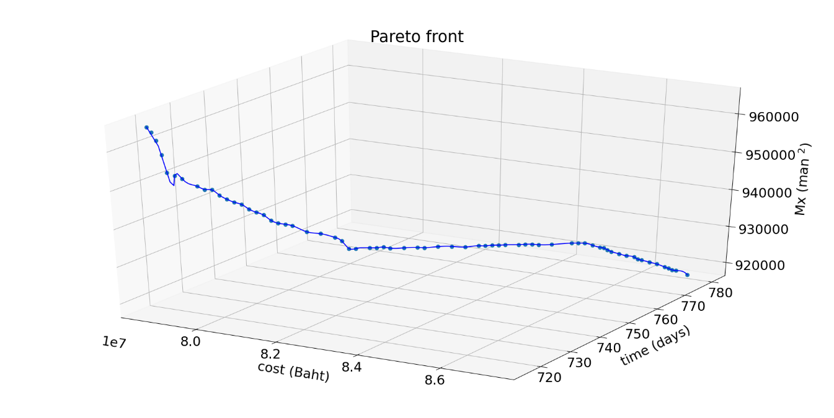

**Figure 10.** Pareto front solutions for 500 generations in 3 objectives.

**Figure 11.** Pareto front solutions for 500 generations in each objective pair.

There are 70 total numbers of optimal solutions as displayed in Table 2. Due to the construction contract termination, optimal solutions for a duration over 780 days are removed. The ability to extend the duration without contract termination would result in better outcomes for both cost and resources fluctuations. Figure 12 displays optimal resource fluctuation moment over GA generations.

**Table 2.** Pareto front solutions.

|  |  |  |  |  |  |  |  |
| --- | --- | --- | --- | --- | --- | --- | --- |
| Solution No. | Cost | Time | Mx | Solution No. | Cost | Time | Mx |
| 1 | 78701296 | 716 | 965714 | 36 | 82230313 | 756 | 925806 |
| 2 | 78718612 | 717 | 964056 | 37 | 82422522 | 758 | 925672 |
| 3 | 78735928 | 718 | 961692 | 38 | 82614730 | 760 | 925346 |
| 4 | 78753245 | 719 | 957788 | 39 | 82806939 | 762 | 924718 |
| 5 | 78770561 | 720 | 952956 | 40 | 82999147 | 764 | 924690 |
| 6 | 78866665 | 721 | 951930 | 41 | 83095252 | 765 | 924434 |
| 7 | 78962770 | 722 | 951030 | 42 | 83191356 | 766 | 924418 |
| 8 | 79154978 | 724 | 948698 | 43 | 83287460 | 767 | 924216 |
| 9 | 79251082 | 725 | 947646 | 44 | 83383564 | 768 | 924112 |
| 10 | 79347187 | 726 | 947372 | 45 | 83575773 | 770 | 923754 |
| 11 | 79443291 | 727 | 945760 | 46 | 83671877 | 771 | 923644 |
| 12 | 79539395 | 728 | 944508 | 47 | 83767981 | 772 | 923458 |
| 13 | 79635499 | 729 | 943500 | 48 | 83864085 | 773 | 923114 |
| 14 | 79731603 | 730 | 942752 | 49 | 84056294 | 775 | 922744 |
| 15 | 79827708 | 731 | 941304 | 50 | 84344607 | 778 | 922526 |
| 16 | 79923812 | 732 | 940276 | 51 | 84440711 | 779 | 922330 |
| 17 | 80019916 | 733 | 939348 | 52 | 84536815 | 780 | 922084 |
| 18 | 80116020 | 734 | 937714 | 53 | 84729024 | >780 | 921826 |
| 19 | 80212125 | 735 | 936752 | 54 | 84921232 | >780 | 921552 |
| 20 | 80308229 | 736 | 936274 | 55 | 85017336 | >780 | 921494 |
| 21 | 80404333 | 737 | 935688 | 56 | 85113440 | >780 | 921134 |
| 22 | 80596542 | 739 | 933630 | 57 | 85209545 | >780 | 920800 |
| 23 | 80788750 | 741 | 932710 | 58 | 85401753 | >780 | 920500 |
| 24 | 80980958 | 743 | 931312 | 59 | 85593962 | >780 | 920228 |
| 25 | 81077063 | 744 | 930128 | 60 | 85786170 | >780 | 920194 |
| 26 | 81173167 | 745 | 927824 | 61 | 85882274 | >780 | 919716 |
| 27 | 81269271 | 746 | 927640 | 62 | 85978379 | >780 | 919604 |
| 28 | 81461480 | 748 | 927430 | 63 | 86170587 | >780 | 919362 |
| 29 | 81557584 | 749 | 927246 | 64 | 86362795 | >780 | 919130 |
| 30 | 81653688 | 750 | 927210 | 65 | 86555004 | >780 | 918650 |
| 31 | 81653688 | 750 | 927210 | 66 | 86651108 | >780 | 918378 |
| 32 | 81653688 | 750 | 927210 | 67 | 86651108 | >780 | 918378 |
| 33 | 81749792 | 751 | 926716 | 68 | 86747212 | >780 | 918094 |
| 34 | 81942001 | 753 | 926384 | 69 | 86843317 | >780 | 918084 |
| 35 | 82134209 | 755 | 926072 | 70 | 87131629 | >780 | 917338 |

**Figure 12.** Relation graph between generation and optimal resource fluctuation.

5. Discussion

This study shows the possibility of applying BIM-MOGA to complex construction projects. It provides optimization data for a project manager to make decisions based on existing data underneath the project during the project lifecycle. NSGA-II is a simple MOGA algorithm which is easy to understand and implement but takes longer computational time. Further research may find other methods of using MOGA algorithms to solve construction scheduling problems compared to the NSGA-II’s result.

5.1. Result Comparison

This proposed model beats the results from the previous research [30] at the 282nd generation, as displayed in Table 3. In the previous research, a linear programming solver (LP Solver) approach was used to retrieve an optimal point at 10,000 generations with the construction duration of 720 days. To improve results, NSGA-II provided better results with a MOGA algorithm, though it takes more computational runtime than the LP solver. Nevertheless, the runtime could be reduced in the future with more powerful computers or parallel programming.

**Table 3.** Comparison tools.

|  |  |  |  |
| --- | --- | --- | --- |
|  | Same Mx score at | # Pareto front | Runtime |
| **LP Solver** | 10,000 generations | 1 solution | 8 hours |
| **NSGA-II** | 282 generations | 70 solutions | 4 days |

**Table 4.** Result comparison to original plan.

|  |  |  |  |
| --- | --- | --- | --- |
|  | cost | time | Mx |
| **Original plan** | 78701296 | 716 | 1009040 |
| **Optimal plan** | 78701296 | 716 | 965714 |
| **Different** | 0 % | 0 % | 4.3 % |

When we looked at the original construction cost and time, we found that optimization is clearly better than non-optimization.

6. Conclusion

This paper provides a systematic BIM-based multi-objective genetic algorithm approach for planning and scheduling construction renovation projects. It was simulated for a governmental project of an extra-large building renovation during 2018-2020. Direct and indirect project costs, actual scheduling and resource usage were tracked and retrieved by the researchers. After the information was modeled as a BIM-based MOGA, the optimization results were displayed as a Pareto front with 70 combinations among direct costs, time usage and resource allocation. The BIM-MOGA also provided less computational time compared to previous research working on BIM with genetic algorithms. The increase in generation provided better results, which this research used at 500 generations. BIM and MOGA worked together through standard spreadsheet files, such as .xls, .xlsx and .csv extensions. The standard file formats are easy for reading, editing, and sharing, which is beneficial when the model’s results need to be sent and the receiver only has standard spreadsheet programs such as Microsoft Excel, Google Sheets, Smartsheet, or Numbers. It creates opportunities for construction experts to develop more robust and efficient tools for construction planning and scheduling using a combination of existing BIM along with MOGA in professional practice. The construction process will benefit from useful information for better decision-making depending on the strategies based on the Pareto front data provided.

**Supplementary Materials:** The following are available online at www.mdpi.com/xxx/s1, Figure S1: title, Table S1: title, Video S1: title.

**Author Contributions:** Conceptualization, P.N., M.K. and P.C.; methodology, P.N., M.K. and P.C.; validation, P.N., S.N. and W.B.; formal analysis, S.N and W.B.; investigation, M.K. and P.N.; data curation, P.N.; writing—original draft preparation, P.N. and S.N.; writing—review and editing, M.K., P.C., K.P.; visualization, P.N. and S.N.; supervision, M.K. All authors have read and agreed to the published version of the manuscript.

**Funding:** This research received no external funding.

**Institutional Review Board Statement:** Not applicable.

**Informed Consent Statement:** Not applicable.

**Data Availability Statement:** Data available on request due to restrictions eg privacy or ethical

**Acknowledgments:** The authors would like to thank Chiang Mai University Library and Optimization Theory and Applications for Engineering SYStems Research Group (OASYS), Chiang Mai University for supporting.

**Conflicts of Interest:** The authors declare no conflict of interest.

References

1. Czmoch, I.; Pękala, A. Traditional design versus BIM based design. In *Procedia Engineering*; Elsevier Ltd, 2014; Vol. 91, pp. 210–215.

2. Mitropoulos, P.; Howell, G. A. Renovation projects: Design process problems and improvement mechanisms. *J. Manag. Eng.* **2002**, *18*, 179–185.

3. Luo, L.; He, Q.; Jaselskis, E.; Xie, J. Construction Project Complexity: Research Trends and Implications. *J. Constr. Eng. Manag.* **2017**, *143*, 4017019.

4. Saad, M.; Baba, S.; Amoudi, O. A suggested solution to improve the traditional construction planning approach. *Jordan J. Civ. Eng.* **2015**, *9*, 185–196.

5. Pūlmanis, E. Public Sector Project Management Efficiency Problems, Case of Latvia. *Reg. Form. Dev. Stud.* **2014**, *11*.

6. Chen, L.; Luo, H. A BIM-based construction quality management model and its applications. *Autom. Constr.* **2014**, *46*, 64–73.

7. Carbonari, G.; Stravoravdis, S.; Gausden, C. Building information model implementation for existing buildings for facilities management: a framework and two case studies. *Build. Inf. Model. Des. Constr. Oper.* **2015**, *1*, 395–406.

8. Khaddaj, M.; Srour, I. Using BIM to Retrofit Existing Buildings. *Procedia Eng.* **2016**, *145*, 1526–1533.

9. Volk, R.; Stengel, J.; Schultmann, F. Building Information Modeling (BIM) for existing buildings - Literature review and future needs. *Autom. Constr.* **2014**, *38*, 109–127.

10. Mill, T.; Alt, A.; Liias, R. Combined 3D building surveying techniques-Terrestrial laser scanning (TLS) and total station surveying for BIM data management purposes. *J. Civ. Eng. Manag.* **2013**, *19*, 23–32.

11. Barazzetti, L.; Banfi, F.; Brumana, R.; Gusmeroli, G.; Previtali, M.; Schiantarelli, G. Cloud-to-BIM-to-FEM: Structural simulation with accurate historic BIM from laser scans. *Simul. Model. Pract. Theory* **2015**, *57*, 71–87.

12. Ipsilandis, P. G. Multiobjective Linear Programming Model for Scheduling Linear Repetitive Projects. *J. Constr. Eng. Manag.* **2007**, *133*, 417–424.

13. Zhang, H. Ant Colony Optimization for Multimode Resource-Constrained Project Scheduling. *J. Manag. Eng.* **2012**, *28*, 150–159.

14. Hegazy, T. Optimization of resource allocation and leveling using genetic algorithms. *J. Constr. Eng. Manag.* **1999**, *125*, 167–175.

15. Chan, W. T.; Hu, H. Precast production scheduling with Genetic Algorithms. In *Proceedings of the IEEE Conference on Evolutionary Computation, ICEC*; 2000; Vol. 2, pp. 1087–1094.

16. El-Rayes, K.; Jun, D. H. Optimizing resource leveling in construction projects. *J. Constr. Eng. Manag.* **2009**, *135*, 1172–1180.

17. Murata, T.; Ishibuchi, H. MOGA: multi-objective genetic algorithms. In *Proceedings of the IEEE Conference on Evolutionary Computation*; IEEE, 1995; Vol. 1, pp. 289–294.

18. Eshtehardian, E.; Afshar, A.; Abbasnia, R. Fuzzy-based MOGA approach to stochastic time–cost trade-off problem. *Autom. Constr.* **2009**, *18*, 692–701.

19. Peng, B.; Flager, F. L.; Wu, J. A method to optimize mobile crane and crew interactions to minimize construction cost and time. *Autom. Constr.* **2018**, *95*, 10–19.

20. Zhao, S.; Li, Z. Multi-objective optimization for construction site layout planning problem under fuzzy random environment. In *Proceedings - 2014 7th International Joint Conference on Computational Sciences and Optimization, CSO 2014*; Institute of Electrical and Electronics Engineers Inc., 2014; pp. 641–645.

21. Monghasemi, S.; Nikoo, M. R.; Khaksar Fasaee, M. A.; Adamowski, J. A novel multi criteria decision making model for optimizing time-cost-quality trade-off problems in construction projects. *Expert Syst. Appl.* **2015**, *42*, 3089–3104.

22. Tachaudomdach, S.; Upayokin, A.; Kronprasert, N.; Arunotayanun, K. Quantifying Road-Network Robustness toward Flood-Resilient Transportation Systems. *Sustain. 2021, Vol. 13, Page 3172* **2021**, *13*, 3172.

23. Zanchetta, C.; Cecchini, C.; Bellotto, C. BIM-Based multi-objective optimization process for energy and comfort simulation: existing tools analysis and workflow proposal on a case study.

24. Faghihi, V.; Reinschmidt, K. F.; Kang, J. H. Construction scheduling using Genetic Algorithm based on Building Information Model. *Expert Syst. Appl.* **2014**, *41*, 7565–7578.

25. Deb, K.; Pratap, A.; Agarwal, S.; Meyarivan, T. A fast and elitist multiobjective genetic algorithm: NSGA-II. *IEEE Trans. Evol. Comput.* **2002**, *6*, 182–197.

26. Salama, T.; Moselhi, O. Multi-objective optimization for repetitive scheduling under uncertainty. *Eng. Constr. Archit. Manag.* **2019**, *26*, 1294–1320.

27. Rao, S. S. *Engineering Optimization: Theory and Practice: Fourth Edition*; 2009.

28. Palisada Corporation *Evolver User’s Guide : The Genetic Algorithm Solver for Microsoft Excel, Version 7*; Palisade Corporation: Ithaca, NY USA 14850, 2015.

29. Ghoddousi, P.; Eshtehardian, E.; Jooybanpour, S.; Javanmardi, A. Multi-mode resource-constrained discrete time-cost-resource optimization in project scheduling using non-dominated sorting genetic algorithm. *Autom. Constr.* **2013**, *30*, 216–227.

30. Nusen, P.; Piyawongwisai, P.; Nusen, S.; Kaewmoracharoen, M. Resource Utilization Optimization using Genetic Algorithm based on Variation of Resource Fluctuation Moment for Extra-Large Building Renovation. In *Article in Press, ACM 6th International Conference on Intelligent Information Technology, ICIIT 2021*; 2021.